Appendix 1
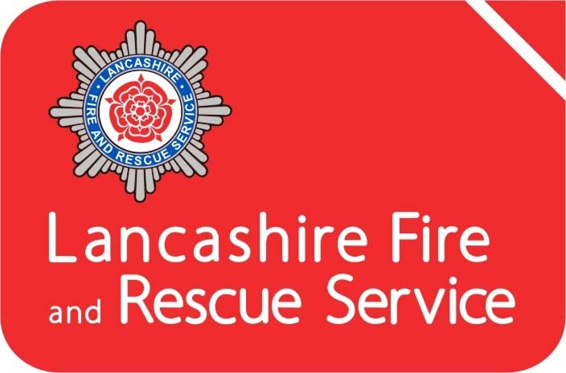

Annual Statement of Assurance 2021-22

Contents
1. Introduction 3
Lancashire Combined Fire Authority 3
The County of Lancashire 4
Lancashire Fire and Rescue Service (LFRS) 4
2. HMICFRS Inspection 6
3. Financial Assurance 6
4. Assurance on Governance 7
5. Operational Assurance 8
Community Risk Management Plan (CRMP) 10
Planning and Performance 10
Consultation 11
Community Risk Management 11
Prevention and Protection 12
Mutual Aid Agreements 15
National Resilience 15
Business Continuity 16
Safety, Health, and Environment 17
Training and Development 18
6 Assurance Declaration 19

Figure 1 - Service Delivery Areas and Fire Station locations 5
Figure 2 - Changes in Fire Risk 2010-2021 12

1. Introduction
The Fire and Rescue National Framework for England (2018) provides overall strategic direction to English Fire and Rescue Authorities (FRA). It sets out the Government’s priorities and objectives and places a requirement on all FRA’s to provide assurance to their communities and to Government on financial, governance and operational matters.
This Statement of Assurance aims to provide the necessary accountability and transparency to the people of Lancashire and evidence that their Fire and Rescue Service continues to deliver under the expectations detailed within both the National Framework and our own Community Risk Management Plan (CRMP).
This statement sits alongside our CRMP, Statement of Accounts, the Annual Governance Statement and the Annual Service Plan and Annual Service Report. It details what measures are in place to assure that the Combined Fire Authority’s performance is efficient, economic, and effective.

Lancashire Combined Fire Authority
Lancashire Combined Fire Authority (CFA) is made up of 25 elected councillors drawn from Lancashire County Council (19) and the unitary authorities of Blackburn-with-Darwen (3) and Blackpool (3). The CFA is responsible under the Fire and Rescue Services Act 2004 for providing a Fire and Rescue Service in Lancashire. This involves the provision, training and equipping our staff to undertake firefighting operations, fire safety work, rescue of persons from road traffic collisions and preparing for our response to other emergency situations. The CFA is the body legally responsible for enforcing the Regulatory Reform (Fire Safety) Order 2005 and is a designated Category 1 responder under the Civil Contingencies Act 2004.
The CFA ensures that the work of the Fire and Rescue Service is efficient, effective and provides value for money. To achieve this, they operate under a framework of five full meetings each year which are supplemented by a number of smaller committees focusing upon Planning, Performance, Resources, Audit and Appeals.
Further information on the afore-mentioned committees is accessible via our website at https://cfa.lancsfirerescue.org.uk/

The County of Lancashire
Lancashire comprises of 14 districts, 12 of which are within the Lancashire County Council area (Burnley, Chorley, Fylde, Hyndburn, Lancaster, Pendle, Preston, Ribble Valley, Rossendale, South Ribble, West Lancashire, and Wyre) and 2 unitary authorities of Blackpool and Blackburn-with-Darwen. The area is home to a resident population of circa 1.53 million people (Census 2021) and is one of the most populated and urbanised shire counties within Great Britain, with a legacy of historical, industrial heritage.
Lancashire covers just over 3,000 square kilometres including 123 kilometres of coastline stretching from Morecambe Bay in the north of the county, down to the sands of West Lancashire in the south. The County has an extensive motorway network, port facilities, nuclear installations and airports and is home to a diverse demographic, with just over 20% of our population being over retirement age and 10% representing Black Minority Ethnic (BME) communities.
The County is bordered by Cumbria to the north and North Yorkshire, West Yorkshire, Greater Manchester, and Merseyside moving from east to south. The major conurbations are Lancaster, Preston, Burnley, Blackburn, Accrington, Chorley, and the seasonal town of Blackpool which receives around 18 million visitors per year.

Lancashire Fire and Rescue Service (LFRS)
LFRS is the service provider on behalf of the CFA. We currently operate from 39 locations (with 58 front-line fire engines and a fleet of specialist vehicles), a specialist Urban Search and Rescue unit, Service Headquarters in Fulwood and our Service Training Centre in Euxton, Chorley. LFRS staff deliver an extensive range of prevention, protection, and emergency response services throughout Lancashire.
To deliver these services, we employ circa 920 operational staff in a wide variety of roles using a variety of shift systems; Whole-time, On-Call, Flexible Day Crewed, Day Crewing Plus and Day Duty.
Our Mobilising and Control Centre moved to North West Fire Control (NWFC), Warrington in 2014. We work collaboratively with Cumbria, Greater Manchester and Cheshire Fire and Rescue Services.
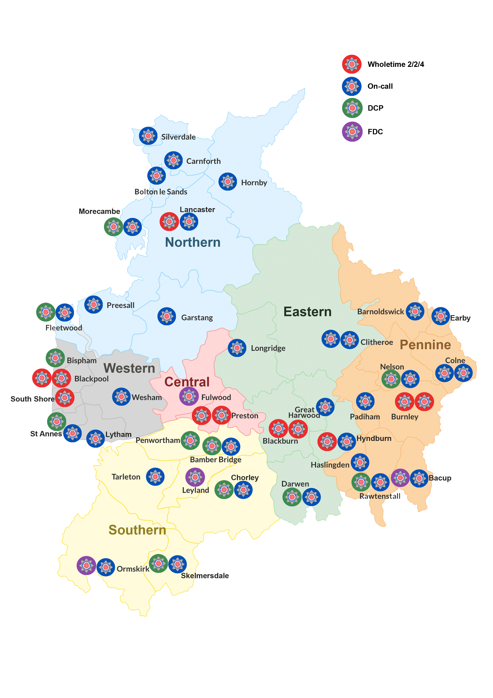Figure 1 - Service Delivery Areas and Fire Station locations

2. HMICFRS Inspection
His Majesty’s Inspectorate of Constabulary and Fire and Rescue Services’ (HMICFRS) assessment examines the service’s effectiveness, efficiency and how well it looks after its people. It is designed to give the public information about how their local fire and rescue service is performing in several important areas, in a way that is comparable with other services across England.
LFRS was in the first tranche of fire and rescue services to be inspected by HMICFRS in 2018. LFRS was rated as ‘outstanding’ for promoting its values and culture. In all other areas, the Service was rated as ‘good’ with no areas that ‘require improvement’ in any of the 11 categories that were assessed.
The 2018 inspection was followed by another in 2020, which was based around LFRS’s response to the COVID pandemic. The report concluded that the service worked closely with the Lancashire Resilience Forum to help keep people in Lancashire safer from COVID-19 whilst ensuring that the service maintained its emergency response service.
Since 2018 LFRS has worked hard to reinforce those areas it was found to be good in and in the most recent inspection, carried out in 2021/2022, LFRS was again rated ‘outstanding’ for culture and values, and rated as ‘good’ in the other 10 categories with no areas that ‘require improvement.’ The results mirror those of the service’s first full inspection in 2018, with the new report highlighting that the service has improved in almost all areas since then.
A full copy of the HMICFRS inspection report can be found on our website.

3. Financial Assurance
All local authority accounts are required to adopt ‘proper accounting practice’ based on either statutory requirements or the code of practice on local authority accounting. These specify the principles and practices of accounting required to prepare a Statement of Accounts that ‘present a true and fair view’.
The Treasurer to the CFA provides publicly available annual accounts which are approved by the Audit Committee.
An independent audit of the accounts is undertaken by an external auditing body, Grant Thornton. The external auditor undertakes a review of the accounts and forms an overall opinion which is published each year. The audit for 2021/22 was conducted in accordance with the Local Audit and Accountability Act 2014 and provided the following opinions –
- An unqualified opinion on the financial statements, which give a true and fair view of the Authority’s financial position as of 31 March 2022 and of its income and expenditure for the year.
- The auditors have not yet completed their value for money work. At the date of preparing the Audit Findings Report they had not identified any risks of significant weaknesses at that stage, and expect to report on conclusion of their work that they are satisfied that the Authority has proper arrangements in place for securing economy, efficiency, and effectiveness in its use of resources.
A copy of the Auditor’s Audit Findings Report for the Year Ended 31 March 2022 is available on our website.

4. Assurance on Governance
The Accounts and Audit Regulations 2015 require the CFA to publish an Annual Governance Statement along with the Authority’s financial statements, following a review of the effectiveness of the internal controls in place. It sets out the key elements of the Authority’s governance framework, how these have been evaluated, the outcome of the assessment of effectiveness and any areas for improvement.
The Audit Committee has previously approved and adopted a Code of Corporate Governance, in line with guidance produced jointly by CIPFA (Chartered Institute of Public Finance Accountants) and SOLACE (Society of Local Authority Chief Executives). The Code defines corporate governance as the way an authority ensures that it is doing the right things, in the right way, for the right people, in a timely, inclusive, open, honest, and accountable manner.
Included within the Code are the following core principles: -
- Behaving with integrity, demonstrating strong commitment to ethical values, and respecting the rule of law
- Ensuring openness and comprehensive stakeholder engagement
- Defining outcomes in terms of sustainable economic, social, and environmental benefits
- Determining the interventions necessary to optimise the achievement of the intended outcomes
- Developing the entity’s capacity, including the capability of its leadership and the individuals within it
- Managing risks and performance through robust internal control and strong public financial management
- Implementing good practices in transparency, reporting, and audit to deliver effective accountability.
The code also sets out the principles which support each of these core elements, as well as how the Authority will address each of these.
The Authority has responsibility for conducting, at least annually, a review of the effectiveness of its governance framework including the system of internal control. The 2021/22 review was supported and informed by the work of both internal audit, which is undertaken by Lancashire County Council, and external audit, which is undertaken by Grant Thornton. This self-assessment formed the basis of the Authority’s Annual Governance Statement for 2021/22 which concluded that Lancashire Combined Fire Authority and Lancashire Fire and Rescue Service has in place an adequate system of internal control which facilitates the effective exercise of its functions, and which includes arrangements for the management of risk, and that no significant governance issues were identified.

5. Operational Assurance
The National Framework outlines the requirement placed upon FRA’s to provide assurance on operational matters which are determined locally by them in partnership with their local communities, citizens, businesses, and others.
FRA’s function within a clearly defined statutory and policy framework of which the key legislative documents defining these responsibilities are:
- Fire and Rescue Services Act 2004
- Civil Contingencies Act 2004
- Regulatory Reform (Fire Safety) Order 2005
- Fire and Rescue Services (Emergencies) (England) Order 2007
- Localism Act 2011
- Fire and Rescue National Framework for England
- The Policing and Crime Act 2017
This section aims to provide assurance that our service is delivered in line with our statutory responsibilities and with due regard to the expectations set out in our CRMP including cross-border, multi-authority, and national incident arrangements. The key components, known as pillars, for operational assurance are as follows:
- Operational Preparedness Assurance - This is the ‘before’ aspect of the assurance framework. It is conducted by the Operational Assurance Team delivered through station-based assurance visits and attending exercises. The focus is on core work that is aligned to reducing risk and our capability to respond to emergencies effectively and efficiently when the need arises.
- Operational Response Assurance - This is the ‘during’ aspect of the assurance framework, which is delivered through assurance monitoring during the response phase of an incident or exercise.
- Operational Learning - This is the ‘after’ aspect of the assurance framework, which is delivered through our debrief systems and by learning from safety events in LFRS, other Fire and Rescue Services, National Operational Learning (NOL), and Joint Organisational Learning (JOL).
The data and findings from these are analysed with key learning provided for staff on a quarterly report to support improvement, and items meeting the criteria are reported to NOL and/or JOL. Additionally, themes are considered for inclusion in training programmes.

Community Risk Management Plan (CRMP)
Our Community Risk Management Plan (CRMP) is a public facing document covering the period 2022-27. This plan is in place to provide the opportunity for LFRS to demonstrate how, we as an organisation, identify and assess all foreseeable fire and rescue related risks and challenges that could affect our communities over the 5-year period and how we plan to mitigate such risks or reduce their potential impact.
Key to the successful identification and management of risk is our ability to maintain a clear and current understanding of the present and future threats to Lancashire’s communities. Risk in Lancashire remains dynamic, constantly changing and differs between districts, which requires varying preventative activities. As a result, no single activity to reduce risk is adequate in all circumstances and a mix of prevention, protection and response activities delivered by a range of organisations is needed to reduce the likelihood of the risk event occurring or to lessen its consequences. This depth of understanding underpins everything we do, driving our governance and planning arrangements; our findings are published within the Strategic Assessment of Risk.

Planning and Performance
To meet the requirements of the CRMP the Service reviews its priorities and targets annually, this supports continual improvement and provides the opportunity to ensure that we undertake activities dependent on the requirements of our environment. Our corporate planning process has been developed to provide a rigorous yet flexible process that allows the Service to assess and respond to opportunities and threats as and when they emerge. Whilst the CRMP is in place to set out the strategic direction of the Service in the medium term, the Service also has in place a forward-looking Annual Service Plan which clearly sets out what we will deliver over the coming 12 months, this is complemented by the Annual Service Report which reflects our achievement against those objectives at the year end.
In addition to this on a quarterly basis, we produce a performance management report known as ‘Measuring Progress’. The content of this report is considered at Senior Management Team meetings and by the Performance Committee of the CFA.

Consultation
External and internal consultation is an essential part of the development of the CRMP and subsequent reviews, and as such we have a clearly defined Consultation Strategy. We use a variety of methods for engaging with community members and for every consultation exercise completed, a summary report is provided to the relevant committee of the CFA. This process ensures that key stakeholders are consulted, involved, and informed of the proposals to ensure that their input is considered within the final plans.

Community Risk Management
Our approach to integrated risk management is supported by the use of modelling. The Office of National Statistics categorises every part of the UK into a small neighbourhood called a Lower Layer Super Output Area (LSOA). There are 941 LSOA’s in Lancashire, each containing an average of 1,500 people. We use information about where fires have taken place in the past and combine this with various social deprivation data to give each area a risk grade.
The information is then used to identify geographic areas at higher risk where a combination of Prevention, Protection and Response activities can have the greatest impact.
This is utilised alongside the provision of tailored Safe and Well visits or Home Fire Safety Check service (HFSC) which is geared towards occupant risk and importantly, to those in greatest need and at greatest risk of fire.
We update the risk model on a regular basis and use the outcomes to direct and re-prioritise our activities. Risk reduction progress over the last 11 years is depicted in the table below.
 | VERY HIGH |  | HIGH |  | MEDIUM |  | LOW |  | OVERALL SCORE
 | SOA Count |  | SOA Count |  | SOA Count |  | SOA Count |  | Risk Score Change
2010 | 60 |  | 118 |  | 310 |  | 452 |  | 36,532
2011 | 60 |  | 114 |  | 303 |  | 463 |  | 36,238
2012 | 53 |  | 100 |  | 313 |  | 474 |  | 35,558
2013 | 40 |  | 93 |  | 301 |  | 507 |  | 34,228
2014 | 32 |  | 95 |  | 306 |  | 508 |  | 33,648
2015 | 41 |  | 86 |  | 281 |  | 533 |  | 33,268
2016 | 32 |  | 76 |  | 314 |  | 519 |  | 32,990
2017 | 25 |  | 74 |  | 321 |  | 521 |  | 32,398
2018 | 22 |  | 74 |  | 321 |  | 524 |  | 32,114
2019 | 21 |  | 68 |  | 310 |  | 542 |  | 31,816
2020 | 23 |  | 74 |  | 324 |  | 520 |  | 32,448
2021 | 21 |  | 61 |  | 338 |  | 521 |  | 31,862
 | -65% |  | -48% |  | 9% |  | 15% |  | -13%
OVERALL CHANGE | OVERALL REDUCTION IN VERY HIGH RISK SOAs |  | OVERALL REDUCTION ON HIGH RISK SOAs |  | OVERALL INCREASE IN MEDIUM SOAs |  | OVERALL INCREASE IN LOW RISK SOAs |  | OVERALL REDUCTION IN RISK SCORE
Figure 2 - Changes in Fire Risk 2010-2021

Prevention and Protection
Our Prevention activities continue to evolve in line with changing societal risk, and are shaped by data, intelligence, and equality impact assessment. Activity remains focussed around the four key themes of helping people to Start Safe, Live Safe, Age Safe and be Safe on our roads, with a continued focus on working collaboratively with other organisations.
Our person-centred Home Fire Safety Check (HFSC) service continues to include Safe and Well brief interventions including, where appropriate, falls risk assessments, alcohol, and mental health advice, and promoting access to other services. This provides the gateway for further collaboration with colleagues in health and social care with a joint aim to improve the health and quality of life for those most at risk in our communities, which in turn reduces fire risk. LFRS remains focussed on identifying those most at risk from fire and continues to refine thematic campaign and referral generation approaches to achieve this e.g., our dementia cafes.
The Service currently has over two hundred approved partners ranging from Lancashire-wide collaborations with health trusts and home oxygen providers, to local third sector organisations. In addition to delivering our role within Community Safety Partnerships our District based Community Safety teams work with Health and Social Care Early Action and Multi-Disciplinary teams to ensure that the fire risk component of complex cases is recognised.
We continue to provide campaign activity which is based on national trends but shaped to meet local needs, drawing increasingly on the reach offered by social media as well as more traditional outlets which meet the needs of Lancashire’s diverse communities.
Education continues to be a priority and the Service has fire, water and road safety packages tailored for all Key Stages of education. Significant work has been undertaken to add Water Safety as a thematic group and we have worked with utility providers and owners of open water to support the introduction of throw lines and water safety boards at high-risk locations. Work continues, with key partners, to raise awareness of water risk across all age groups, but particularly teenagers.
LFRS remains a member of the Lancashire Road Safety Partnership and plays a key part in the delivery of Road Safe, Wasted Lives and Safe Drive Stay Alive education sessions to Lancashire’s young people. The Service also runs and supports a wide range of campaigns for all road users based on the National Police Chiefs Council campaign calendar.
We continue to provide the Princes Trust Team program and have Fire Cadet Units at a range of locations across Lancashire, complemented by a range of other youth engagement activities tailored to local need.
Our Incident Intelligence Team continues to investigate fires, gathering evidence to assist arson investigations, and intelligence to drive the continual development of prevention activities which keep pace with the perpetually evolving nature of risk in our society. We share intelligence with organisations such as Trading Standards, Building Research Establishment and the Office for Product Safety and Standards so benefits are felt further afield.
We will continue to develop the training we provide our staff to ensure we play our part in tackling broader issues such as modern slavery, serious violence (a new duty) and safeguarding those at risk of harm or radicalisation.
The Grenfell Tragedy in 2017, and the resultant public enquiries and technical reviews, has initiated the most far reaching and fundamental changes to Building Regulations and Fire Safety legislation seen in decades. The enquiries have exposed extensive failures in the way the built environment has been designed, constructed, and regulated over the past two decades and the requirements to address these historical failings now extend to all aspects of the construction industry and regulators. Following a period of review and consultation, legislative change is now taking place and LFRS has invested in a Protection Transformation Team to ensure it is well placed to meet future challenges. Specifically, the Service received additional regulatory powers in 2021 with respect to existing residential buildings and the suitability of their fire safety management systems, fire doors and external walls (including cladding and balconies). These were followed in 2022 with additional regulations for some residential buildings with respect to information supplied to residents. This includes boxes containing emergency plans, improved way-finding signage for firefighters, fire door maintenance and requirements to proactively share building plans and information on firefighting equipment operational status (lifts and smoke control etc).
In 2023 the Service will also become a joint regulator with the Health and Safety Executive and Building Controls at all stages of the design, construction, occupation, and operation of Higher Risk Residential Buildings. These advances will be undertaken alongside complementary improvements in Building Regulations and increasing competence expectations of everyone in the construction and regulatory sectors.
LFRS is investing in developing a highly skilled Protection workforce to ensure we are equipped to deal with these changes. Whilst this increased focus on the safety of residential buildings is welcome, such buildings make up only a proportion of Lancashire’s built environment, and the Service will continue to utilise a Risk Based Inspection Programme (RBIP) to identify the wider range of premises at risk from fire and undertake fire safety audits to assure compliance.
Whilst support to business and commerce remains a priority, we will maintain the ability to enforce and indeed prosecute where fire safety law has been ignored or flouted. Business support will continue to be provided by our Business Safety Advisors, campaign activity and website support, and we will continue to contribute to the principles of better regulation through our Primary Authority Schemes.
Whilst specialist and highly skilled Fire Safety Inspectors will undertake ‘audits’ we have increased our ability to ‘check’ compliance through our Business Fire Safety Check services which is undertaken by our Operational Crews. These visits evaluate simple measures linked to effective fire safety management and where there are failings that cannot be addressed at the time these will be referred on to specialist inspectors. These visits also provide an opportunity to collect risk information and provide arson risk reduction advice.
Through all these improvements, and how we use technology to support our protection activities and connect these to the quality of our operational response and training, LFRS is committed to taking a detailed and holistic approach to transforming Protection Services and adapting to regulatory change.

Mutual Aid Agreements
The National Framework states that Fire and Rescue Authorities must make provision to respond to incidents such as fires, road traffic collisions and other emergencies within their area and in other areas in line with mutual aid agreements. LFRS maintain mutual agreements for reinforcements with our five bordering Fire and Rescue Authorities - Cumbria, Greater Manchester, Merseyside, North Yorkshire, and West Yorkshire. These agreements are periodically reviewed to maintain currency and provide optimal response arrangements.

National Resilience
For the purposes of this document, National Resilience (NR) is defined as the capacity and capability of Fire and Rescue Authorities to work together and with other Category 1 and 2 responders to deliver a sustained, effective response to major incidents, emergencies, and disruptive challenges, such as (but not limited to) those identified in the National Risk Register of Civil Emergencies. It refers to risks that need to be planned for on a strategic, national basis because their impacts and consequences would be of such scale and / or complexity that local resources would be insufficient, even when considering mutual aid arrangements.
LFRS is a signatory to the National Mutual Aid protocol and has deployed assets to major incidents outside the region. The costs of such mobilisations are borne by the FRA within whose area the incident occurs and are therefore re-claimed by LFRS.
We remain subject to the NR audit processes which test the various aspects of our NR capabilities. NR has transferred from The Home Office to Merseyside Fire & Rescue Service as the Primary Authority.

Business Continuity
Business Continuity Management (BCM) is an integral part of our corporate risk management process. In relation to BCM processes and procedures, all FRA’s must satisfy the requirements of both the Civil Contingencies Act 2004 and Fire and Rescue Services Act 2004.
We are required to ‘write and maintain plans for the purpose of ensuring, so far as reasonably practicable, that if an emergency occurs the Authority is able to continue its functions’. This includes periods of industrial action.
In order to ensure that Lancashire Fire and Rescue Service comply with both pieces of legislation, our BCM complies with the Business Continuity Institutes’ Best Practice Guidelines. This provides a framework through which:
- Critical processes are identified
- Assessments of both internal and external risks which may impact on business
continuity are made
- Strategic, Tactical, and Operational Plans have been produced to ensure an acceptable level of service can be maintained following disruption
- Procedures are developed to invoke the BCP
- Arrangements are made to test the BCP
- All key personnel are trained to understand their role within the plan
- Responsibilities are clearly identified and assigned.
Each year the plans are reviewed and tested to ensure our plans are fit for purpose. The protracted Coronavirus pandemic demonstrated the Service’s ability to deal with a Major Incident, whilst at the same time responding to other emergencies in a timely manner and continuing with business as usual, as much as reasonably practicable.

Safety, Health, and Environment
The Combined Fire Authority meets regularly to consider local and national Safety, Health, and Environment issues and to provide strategic political leadership to the Service. The Authority has overall responsibility for the effective governance of Safety, Health, and Environment (SHE), including:
- Agreeing the SHE Policy which outlines their commitments and ensuring adequate resources are available for the establishment, ongoing implementation and control of a Health and Safety Management System (HSMS) and Environmental Management System (EMS).
- Providing a clear direction for the Executive Board and Senior Management Team to establish policies and manage health and safety and environmental responsibilities effectively.
- Monitoring performance through receipt of the Annual SHE Report, to provide governance and assurance that an effective HSMS and EMS is operational within LFRS.
Our HSMS is based on the model Plan, Do, Check, Act laid down in the Health and Safety Executive publication HS(G)65 – Successful Health and Safety Management and written and implemented to the International Standard for Health and Safety Management Systems, ISO 45001:2018. The EMS is written and implemented to the International Standard ISO 14001:2015. Certification for both standards has been in place since 2011/12 with re-certification taking place every 3 years followed by annual surveillance audits. The last successful audit took place in 2022, where certification was extended with no non-conformances identified by the external audit team. As part of the audit process, the auditors visit a range of stations and departments and examined the ‘Full provision of fire, rescue and supporting services across Lancashire’ delivered by the Combined Fire Authority from a health and safety and environmental perspective.
Each year a performance review of Safety, Health and Environment is carried out and reported to the Combined Fire Authority in the Annual SHE Report. Part of business-as-usual is the review of all policies, procedures, instructions, support for staff wellbeing and guidance to ensure that we continue to meet our legal obligations in respect of safety, health and environment and we validate this by a system of internal and external audits. To ensure continuous improvement is made in both the HSMS and EMS, we have developed an action plan to assist in delivering future improvements.

Training and Development
Lancashire Fire and Rescue Service Training and Operational Review policy is designed to provide training and development to personnel to enable the organisation to fulfil its vision of 'Making Lancashire Safer'. Training is based on the needs of the organisation with a strong focus on ensuring that personnel are safe and competent in the delivery of the prevention, protection, and response services we provide.
The training programme considers learning identified through our own operational review processes, as well as from reports describing learning from events of national significance. The Training and Operational Review department supports continual learning and organisational development through a wide range of programmes tailored to role and responsibility, as well as managing the selection processes which identify managers for advancement. Ongoing development and maintenance of competence is a key focus, and this is facilitated through a robust maintenance of skills programme linked to an e-learning system which is continually updated.
Trainers are selected and developed across an extremely diverse variety of specialisms, ranging from the intricacies of boat handling and rope rescue, through to the complexities of mounting a successful fire safety prosecution. Where necessary, support is commissioned from specialist providers.
The Training and Operational Review Department work in conjunction with other Departments within the Service, such as Human Resources and the Safety, Health, and Environment Department, to provide training and development for all members of the Service. There is a particular focus on Leadership Development across the Service.

6 Assurance Declaration
The Chairman of Lancashire Combined Fire Authority and Chief Fire Officer of Lancashire Fire and Rescue Service are satisfied that the Authority’s financial, governance and operational assurance arrangements are adequate and operating effectively and meet the requirements detailed within the Fire and Rescue National Framework.
Justin Johnston - Chief Fire Officer David O’Toole – CFA Chairman

Date:

